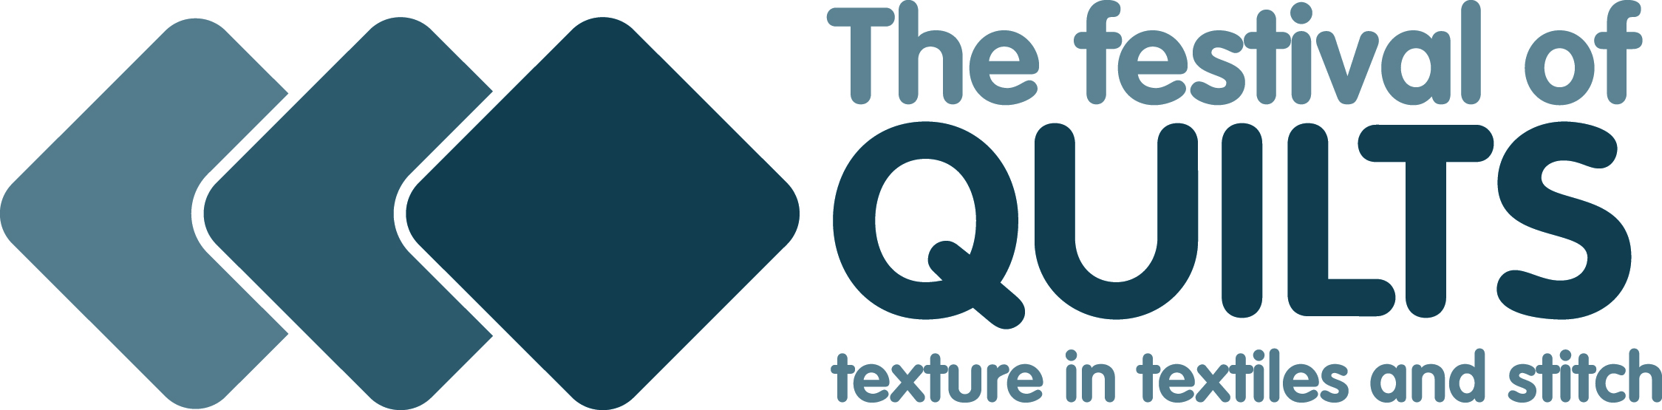

Code 319

Mola Patchwork by Hand

***Tutor: Mick Stead***

Layers of fabric are sewn together; the design is then formed by cutting away parts of each layer. The edges of the layers are then turned under and sewn down using thread the same colour as the layer being sewn using tiny blind stitches.

**Half day workshop**

Materials Kit can be provided, cost £5 payable to the tutor on the day of class. If kit required, please let tutor know via email (hms.stead@tiscali.co.uk)

**All participants will need to bring:**

* Piece of dressmakers tracing paper 16 x 18 Inches
* Needles
* Scissors Small

**Participants not purchasing Materials Kit will need to bring their own material:**

* Plain Fabric 1 Square, 16 x 18 Inches, dark colour for the top i.e., Black, Maroon, Navy Blue

2 Squares, 16 x 18 Inches, bright colours i.e., Red, Green, Orange

1 Square, 6 x 6 Inches, dark colour for the top i.e., Black, Maroon, Navy Blue. See Note

2 Squares, 6 x 6 Inches, bright colours i.e., Red, Green, Orange. See Note

Note:- These squares will be used to make sample pieces so scrap pieces would be OK.

* Sewing thread to match colours chosen
* Sewing Thread for tacking

**For further information contact: Mick on E.** hms.stead@tiscali.co.uk

